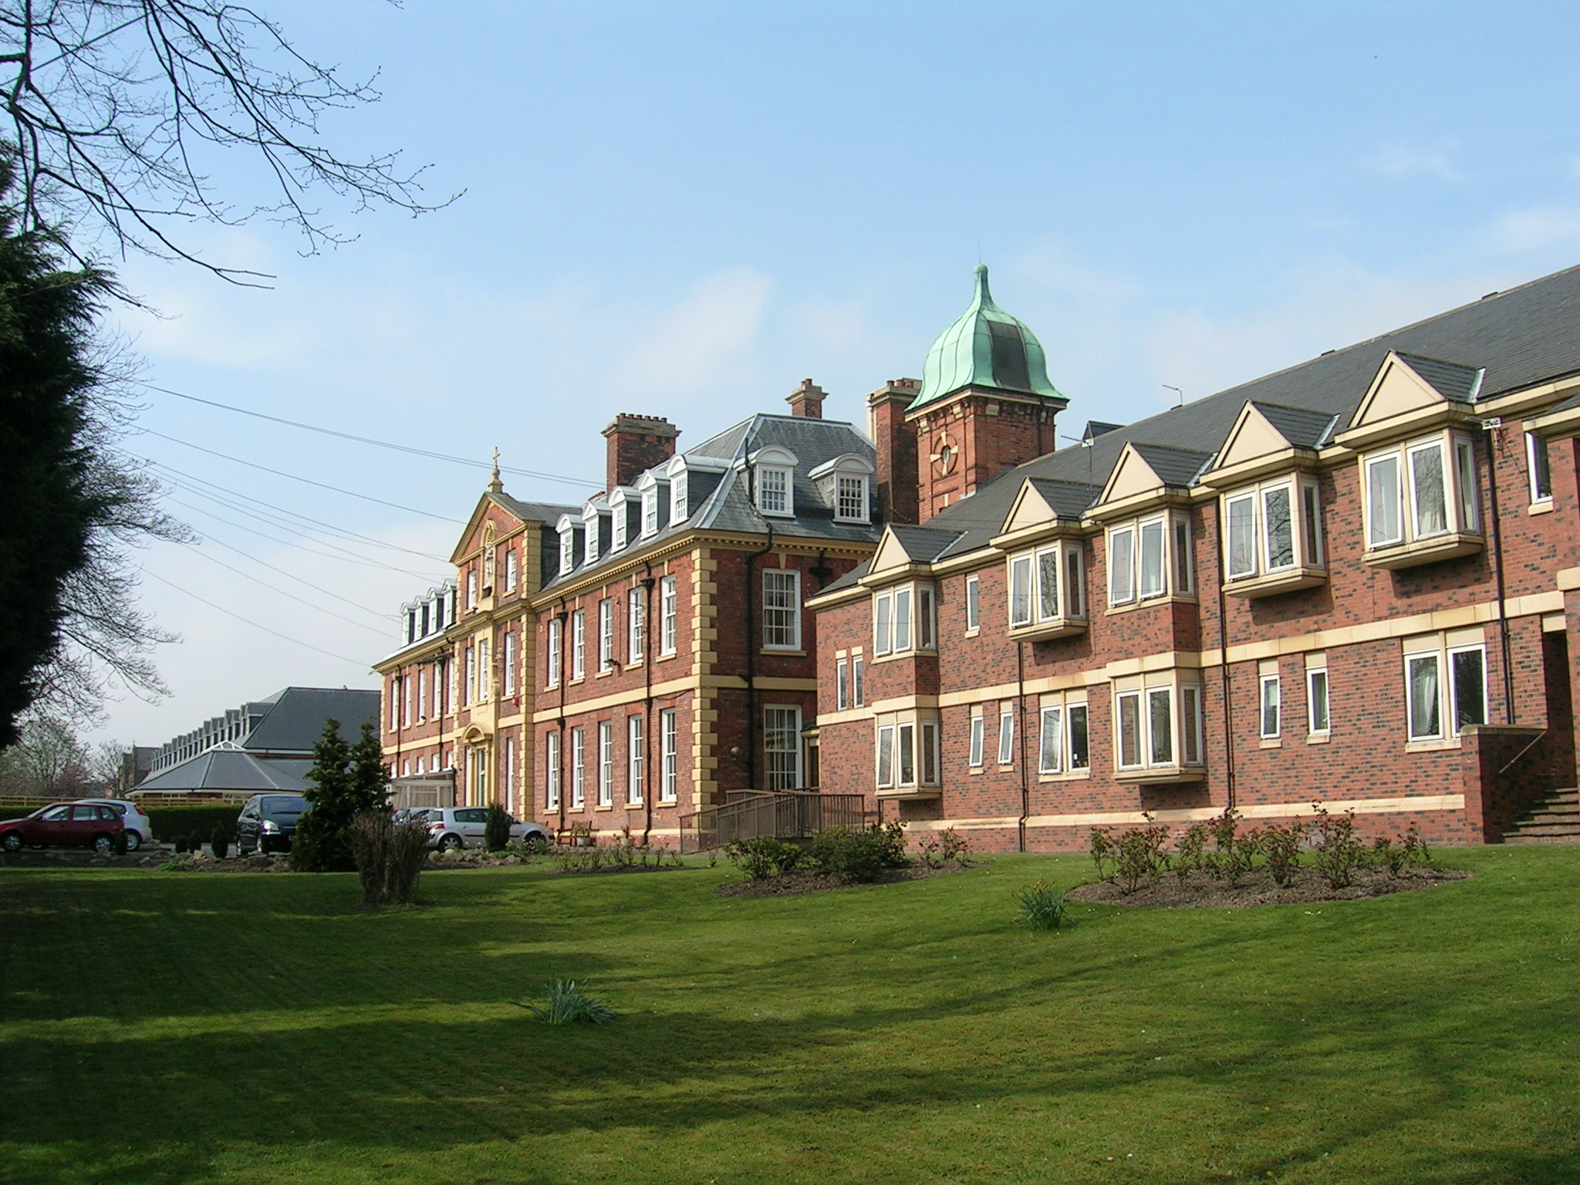

REGENT HOUSE
Regent House is a 17 bedded Unit set within its own grounds adjoining Victoria House Care Centre, and offers a comprehensive, specialist rehabilitation and recovery-focused service designed to treat males with enduring mental health needs. Regent House offers residential, rehabilitation and nursing care for males with mental health needs.
Regent House is led and overseen by a dual-qualified Unit Manager Social Work/Mental Health Nurse working with a dedicated team of registered Mental Health Nurses and support workers.
Our professional and highly-skilled team can provide you with advice, support and therapeutic techniques designed to suit your individual needs. The staff at Regent House work exceptionally hard to ensure that residents, who live here, have all their needs met either mentally or physically. We are passionate about our service users’ happiness.
All Regent House staff were carefully selected for their skills, training and attitude. Staff are extremely friendly and go that extra mile to build therapeutic relationships with the service users. We support our residents to embrace their personal interests and also acquire new interests to broaden their horizons with the aim to achieve a more positive, fulfilled life.
Regent House is within walking distance and excellent access routes to the town centre of Middlesbrough. Regent House offers a very warm and welcoming atmosphere with wonderful views of Albert Park.
Our building is divided over two floors and has modern facilities and amenities. The upper floor has 10 spacious bedrooms with modern decor. The ground floor comprises 7 large bedrooms, a separate lounge area with balcony leading into the grounds. There is a fully equipped kitchen/dining area, laundry room and an ADL kitchen for our service users to learn essential cooking skills ready for their future discharge.
The unit has a total of 17 beds, (3 en-suite) – all other rooms have a wash basin area. The upper floor has 1 large communal bathroom/wc with rising bath for those who may have any mobility issues. There are 2 single shower rooms and additional wc facilities.
Regent House service users are encouraged to personalise their own rooms with their own pictures and furnishings to enable them to feel at home. There are also a number of other rooms to choose to relax and unwind in, including a communal lounge.
We work closely with outside agencies which helps service users to transfer effortlessly between the most appropriate care, meeting individual needs, enabling recovery and re-engagement within the community and maximising life opportunities.
Philosophy of Care
Staff at Regent House will set out to enable the service user with enduring mental illness to acquire the life and social skills necessary to live as independently as possible within their own community.
The vision of this Unit is to create a working care pathway focusing on recovery of the individual that will offer the service user access to the rehabilitation service that may best meet their needs.
Our aim is to provide recovery in the least restrictive environment, as close to home, family and friends as possible.
Our Philosophy of Care is to respect different beliefs, to inspire motivation, be innovative and creative in choices and independence, to see the person beyond the label, to be honest and open, to listen and learn, to offer purposeful activity and to provide a relaxed and homely environment, to show life after rehabilitation.
Admission Criteria
- Males aged 18 and over.
- Primary diagnosis of a severe and enduring mental illness.
- Behaviours that involve risk of harm to self or others, life skills problems and self-care, vulnerability and social or relationship problems.
- People who have successfully or partially completed treatment in secure services but who may need relapse prevention or further rehabilitation before returning to the community or move to supported living.
- People who require care and treatment in a calm and therapeutic environment following repeated episodes of acute illness, including patients who have required treatment in PICU and acute in-patient environments.

For further information on Regent House, please contact a member of our team on
01642 242975
Park Road North
Middlesbrough
TS1 3LD

Email: rh@keyhealthcare.co.uk

Alternatively, call in to the Unit for a friendly, informal chat.

